St Brigid’s College

Year 12 VCE English 2017

Course Revision & Examination Preparation

Contents
Preparation for October Trial English Exam
- The English Exam – key information

Exam Preparation
- Section A – Analytical interpretation of a texts
  - ‘The Complete Maus’ by Art Spiegelman,
  - ‘Island: collected stories’ by Alistair MacLeod
- Section B – Comparative analysis of texts
Pair 7 - ‘Black Diggers’ and ‘The Longest Memory’
- Section C – Argument and persuasive language

Student Name _____________________________________

Preparation for the October trial English exam
The English Exam – Key Information

Details of the VCAA exam
- Exam date: Wednesday 1st November 2017
- 15 minutes reading time – 9.00am to 9.15am
- 3 hours writing time – 9.15am to 12.15pm

October Trial Exam
- Option of 2 exam papers
- You are permitted to complete both
- Please attempt the INSIGHT PRACTICE PAPER FIRST
- Complete the practice paper in the morning session of the trial exam period:
  - Reading time – 9.30am to 9.45am
Keep in mind…
The essential principle of exam assessing is to reward insights, knowledge and skills, along with the reading and writing skills utlised in each student response. Assessors are aware that this work is first-draft and that students are working within a time limit. Students should still allow time to read over and proofread their answers, freely annotating and enhancing their writing.
  - Writing time – 9.45am to 12.45pm

Structure of the exam

Section A: Analytical interpretation of a text (20 marks)
- ‘The Complete Maus’ – Art Spiegelman
- ‘Island: collected stories’ – Alistair MacLeod
The task:
- Write one analytical essay response on one of the above texts

Section B: Comparative analysis of texts (20 marks)
- Pair 7 – ‘The Longest Memory’ (Fred D’Aguair) and ‘Black Diggers’ (Tom Wright)
The task:
- Write one comparative essay response on BOTH of the above texts

Section C: Argument and persuasive language (20 marks)
The task:
- Write one analytical essay response on the unseen persuasive material provided in the exam paper

Answer book
- Students will hand-write their responses in a specially provided English Answer Book
- The book has specific space for each section of the exam
- The Answer Book is arranged in the same order as the exam, however you are not required to write your responses in this order. All responses need to be written in their correct section.
- Most students will start with Section C having read the unseen material for analysis at least twice in the reading time.

Timing
- Each section is worth an equal 20 marks each
- Allocate an equal amount of time to each response (1 hour)
- However, be aware of sections that may require more time and adjust your time allocation as necessary:
  - For example:
Reading time – 15 minutes ‘THINKING TIME!’
2 minutes – Section A: read 4 text response questions – identify potential for you; eliminate others
2 minutes – Section B: read the 2 topics for Pair 7 and narrow down on core issues/ideas
3 minutes – Section C: Argument Analysis – Read background information and confirm audience, intent, context, form. Read article/s and ‘read’ the visual; note how the arguments unfold
2 minutes – Section A: choose the topic you can challenge the best (how will you argue your case?)
2 minutes – Section B: choose the topic you can challenge the best – consider ideas, themes, quotes etc.
4 minutes – Section C: Re-read article/s – look for links/connections in arguments

Writing Time – 3 hours
45 minutes – Section C: immediately once writing time commences – include 2-3 minutes planning
70 minutes – Section B: allow extra time to ensure your comparative response is planned and well structured
55-60 minutes – Section A: allow a full hour and include planning and editing time in this hour
5-10 minutes – Proofreading: always allow time at the end to proofread all of your work

Preparing for the exam
Even though the topics are unseen, there are many things students can do to maximise their exam performance. Timed practice can be extremely beneficial and impactful when preparing.

Section A: Analytical interpretation of a text
- Students should re-read List 1 (Unit 3) texts before the start of term 4 to sharpen their textual knowledge and to deepen their insights and personal engagement with the text.
- Students should revisit class notes and other materials to assist in focusing on the inner world of the text.

In preparation for the exam, the following essential questions should be posed for each text:
- How is the reader/viewer taken into the world of the text?
- How is the storyline developed for the reader/viewer?
- Why has the text been sequenced in a linear or fragmented way?
- Does the text develop in a predictable or unexpected way?
- What is the intended impact on the audience and how is this made apparent?
- Are events presented through a known first-person narrator or through a distant or omniscient and undisclosed third-person narrator?
- Why has the writer/director chosen such a narrative approach?
- How are the main characters presented and to what extent do they change or develop through the course of the text?
- What are the central relationships that seem to permeate the text most?
- How has language been used in the text and what is significant about this?
- How have the concerns and nature of the times in which the text is set been conveyed to the reader/viewer?
- What major issues, values or themes are raised and how is this achieved?

It is essential that students develop their topic 'attack skills' by regularly writing practice analytical essays. This practice should be intensified in the weeks leading up to the exam, especially over the term 3 vacation and in early term 4.

In addition, it is useful to:
- create a series of cue cards focusing on specific elements of each set text
- create a set of quotation cue cards for each text
- create posters that visually capture essential elements of each set text, including pivotal relationships and supporting quotations and display these strategically at home
- generate a collection of different essay topics on each text, including all relevant previous official VCAA topics.

Section B: Comparative analysis of texts
List 2 (Unit 4) paired texts should be re-read after they have been studied in class. As this exam section indicates, a 'Comparative analysis of texts' is required, and students must demonstrate that they are adept at analysing both texts.

In preparation for the exam, the following reflections should be made on each text and as a means of comparing them.
- Are events presented through a known first-person narrator or through a distant or omniscient and undisclosed third-person narrator in each text?
- Are the events presented chronologically or in another manner in each text?
- What is significant about the period of history in which the text is set and the place and situation of each text?
- How important are the actions of the main characters in conveying the key elements and messages of each text? Which brief quotations best reveal these major ideas?
- How do the language and imagery of each text impact the reader/viewer?
- What major ideas, issues or themes are raised in each text?
- How are the major ideas, issues or themes in each text essentially conveyed?
- What significant similarities exist between the texts, with respect to the ideas and issues presented?
- What are the differences in the nature of the main ideas and issues raised?
- How are the main ideas and issues presented in each text and what makes them different and distinct?
- How is the reader/viewer left at the end of the text with respect to these main issues, themes and ideas? Are the texts hopeful or otherwise?

In addition, it is useful to:
- create a series of cue cards focusing on specific elements of each set text
- create a set of cue cards and on each card write a quotation from each text that shows juxtaposing ideas, issues or themes
- create tables which overtly compare and contrast key elements of the texts.

Section C: Argument and persuasive language
This section is marked on depth and breadth of skill acquisition. To appropriately prepare for Section C of the exam, students should continually practise their skills of argument and persuasive language analysis. They should also practise closely reading different types of persuasive texts including letters to the editor, editorials, feature articles and opinion pieces, as well as illustrated texts, tables and graphs.
When reviewing their practice essays, students should consider the following questions.
- Have I clearly identified and explained the persuasive impact of language (words and visual) on the targeted audience?
- Have I consistently used succinct and fully-integrated quotations as precise evidence?
- Have I appropriately explained the intentional argumentative structure of the text?
- Have I avoided inappropriate summary or paraphrasing of the content?
- To what extent has the persuasive impact been explained, rather than labelled (e.g. if rhetorical questions have been used, what impact has this device had on the target audience)?
- Have I explained how the language operates to reinforce the argument (rather than simply listing the language elements)?

Reviewing and editing your writing…
When reviewing your essays, you should ask yourself the following questions:
- Are sentences used accurately or are there flow-on sentences which require adjustment?
- Has sentence length been varied?
- Is paragraphing clear and accurate?
- Is the logic and organisation in the writing clear and apparent, or should there be adjustments and changes?
- Are there identifiable spelling errors, especially in the case of homonyms, which require changing?
- Should some words be replaced or used differently to enhance clarity and precision?
- Should other words or phrases be inserted to better convey meaning?
- To what extent is the vocabulary suitably complex?

Exam Assessment Criteria – know it and how to meet it!
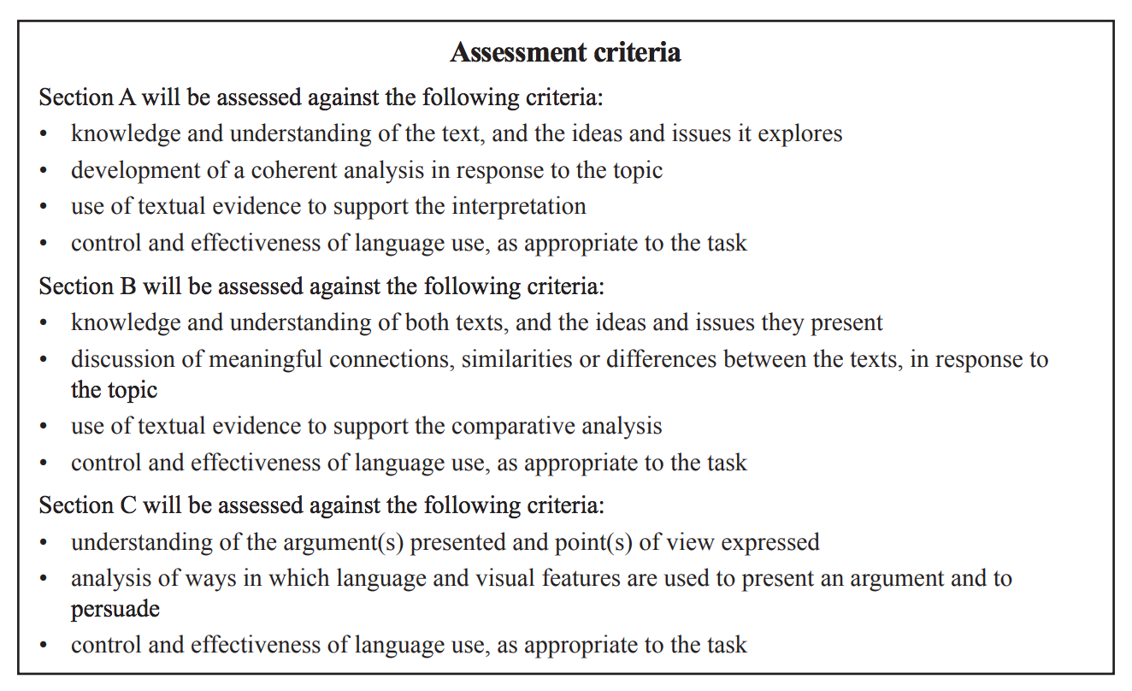

Examination Preparation

Section A – Analytical interpretation of a texts (20 marks)
- ‘The Complete Maus’ by Art Spiegelman, OR
- ‘Island: collected stories’ by Alistair MacLeod

Analysing texts
- Focus on the key elements of the two single texts, The Complete Maus and Island
- Consider the key building blocks used to CONSTRUCT these texts.

Examine the following core elements:
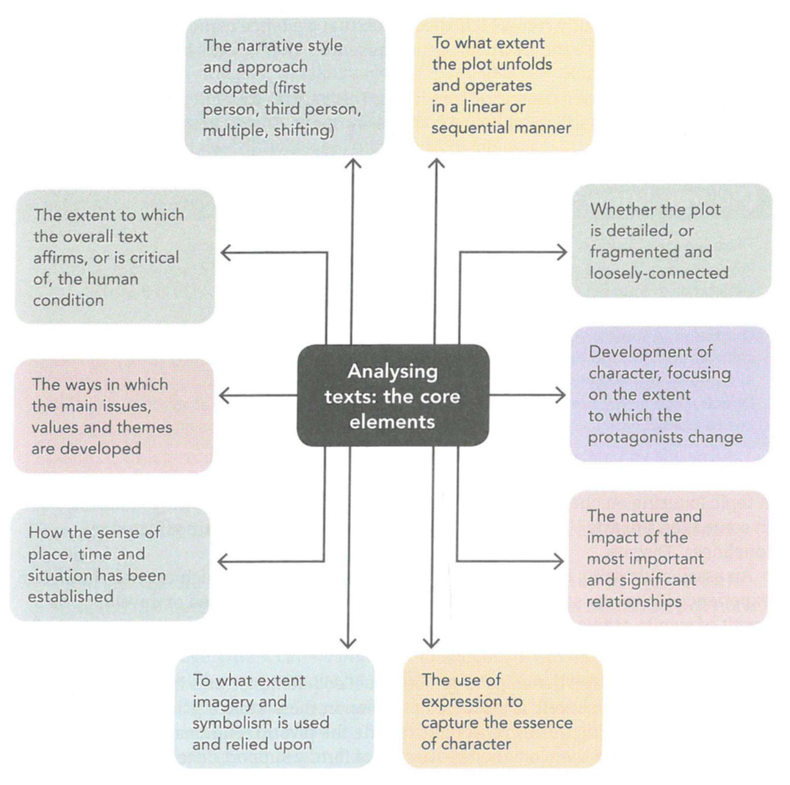

The topics
Approaching a topic, students should consider:
- To what extent they endorse, agree with or take issue with the central view being presented about this text;
- How their own analysis and study of this text will be supported through specific textual evidence.
An argument should be constructed, developed and proven throughout the essay, in which the topic is fully resolved. If specific textual evidence cannot be provided to support and endorse the viewpoint being presented, then it cannot be seen as acceptable or reasonable.

Topics typically have a central or core focus. This central element should be directly addressed in the contention with which the essay opens. Some central elements are explored below:
CHARACTERISATION
A topic focusing on characterisation might be:

‘Hard times and hard choices reveal the resilience of the characters in Island.’ Discuss.

An essay addressing this topic would examine the degree to which central characters demonstrated resilience and to what extent their resilience changed or developed as a result of events or relationships.

RELATIONSHIPS
A topic focusing on relationships might be:

'MacLeod demonstrates how families can be both relied upon as well as a source of tension in these stories.' Discuss.

An essay addressing this topic would examine the pivotal relationships within families which drive the plot, and the themes of family support or tension which permeate the text.

STRUCTURE
A topic focusing on structure might be:

‘Maus would not be so powerful if it were a conventional novel.’ Discuss.

An essay addressing this topic would analyse and explore the significant organisational choices made by the artist/author and the impact of these choices on the audience.

NARRATIVE STYLE AND APPROACH
A topic focusing on narrative style and approach might be:

How does Spiegelman use visual clues in Maus to alert us to the plight of his characters?

An essay addressing this topic would examine how the visual clues have been used and why it has been presented through the eyes of a specific character (or a series of shifting characters) and the degree to which this approach enables readers to better understand the text.

IMAGERY AND LANGUAGE
A topic focusing on imagery and language might be:

'It is Speigelman’s use of symbols in his graphic novel that most strongly captures his messages.' Discuss.

An essay addressing this topic would analyse and examine the impact of recurring or distinctive visual descriptions or symbols on the audience.

VALUES AND BELIEFS
A topic focusing on values and beliefs might be:

‘Through Maus, Art Spiegelman shows us that the demons of the Holocaust will haunt us forever.’ Discuss.

An essay addressing this topic would examine and explain the deeply-held and quintessential attitudes and moral principles which permeate and characterise the text.

ISSUES AND THEMES
A topic focusing on issues and themes might be:

‘Despite the sadness depicted in Maus, it is ultimately a story of hope.’ To what extent do you agree?

An essay addressing this topic would examine and analyse the major concerns raised in the text, which transcend its inner world and are overtly advocated by the writer.

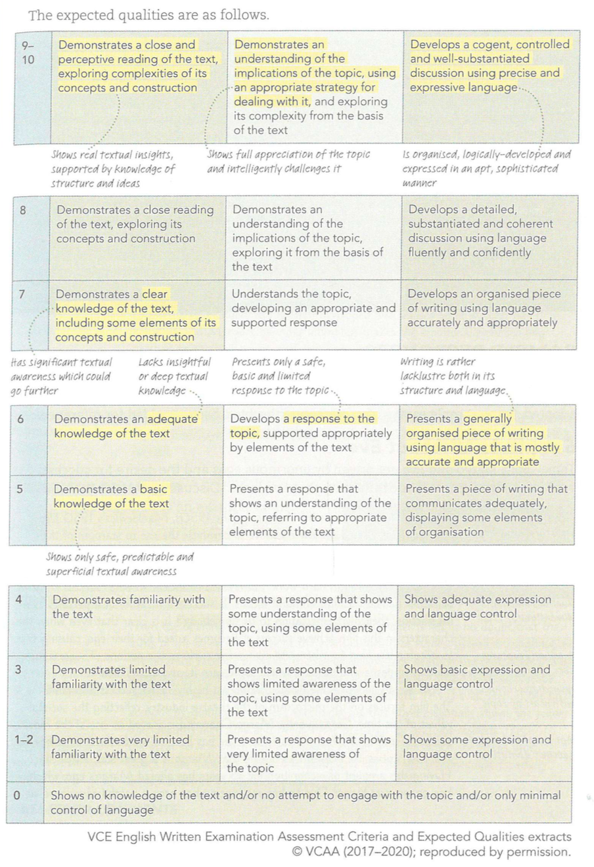

SECTION A EXAM TIPS – Check off the items as you address them in your revision!
Below are exam tips to assist students to analyse texts and prepare for the final year exam.

- Students should be flexible about the single List 1 text on which they intend to write in the exam. Most students will have a preferred text on which they wish to write. However, it is wise to have a back-up plan for their less-preferred text. Students may not find a topic with which they feel confident on their preferred text, so having an alternative text is an advantage. The second text should be viewed as an 'insurance policy'.

- Students should re-read both texts by the start of term four. This re-reading should focus on challenging their initial reading and reflecting on the close study of the text in class. There should also be a conscious revisiting of the finer details of the text, including the language, structure and narrative intentionally used.

- Students should memorise between 25 and 35 key quotations from each text. These need to be succinct, should come from different parts of the text and reflect different aspects of the text.

- Students should identify key parts of each text that provide insights into the ways in which the main protagonists develop and change, and also into the key issues, views and themes which lie at the heart of the text.

- Students should practise their question 'attack skills' for different styles of question and topic focus – this means unpacking questions critically!

- Students should write full practice essays as timed pieces. That way the (approximately) 56 minutes of writing time in the exam will become a familiar time-period, which has been rehearsed and will help students to manage their time.

- Students should use the published exam criteria (and expected qualities) to target areas for improvement. This should be seen as an ongoing skill-development approach.

- In the actual exam, students should avoid selecting a topic only because it seems ‘easier’ or more familiar. Sometimes a topic may seem easier, but that could just be a misreading of what it is actually asking. More familiar topics, which may echo essay topics answered at school, can often lead to a student rewriting a previous essay, and missing the nuances of the actual topic of the exam. The most suitable topic is one which a student can most effectively challenge with fresh ideas and careful consideration. All topics should be viewed as presenting a position, or stance, which should be thoughtfully considered and responded to. Challenge yourself to ‘unpack’ and respond to topics that you would otherwise avoid.

- Students should avoid making a hasty choice of topic. The 15 minutes reading time allows the opportunity to make a tentative initial choice and then to return to confirm or change this later. Students need to ensure that they have sufficient precise textual evidence, including specific quotations, with which to support the stance they intend to pursue. Practice using your strategies for the 15 minutes reading time.

- Students should ensure that the contention to be argued covers all aspects of the selected topic, and is reflected in the emerging topic sentences for each body paragraph. Go over all previous SAC and practice responses to critically reflect on this.

And these… (from Insight textbook, page 229)

- Create a plot summary as a flow chart or in a table

- Revise the correct terms for narrative structure (Insight textbook, p.5) and know where the crisis points, climax and resolution occur in your text/s.

- Summarise character details using concept maps and the like

- Summarise the text’s themes, ideas and values: how are these presented: through the characters’ experiences? Environments? External forces? Write clear statements about the values that the text supports.
‘The Complete Maus’ by Art Spiegelman

Character Map – know the characters and relationships
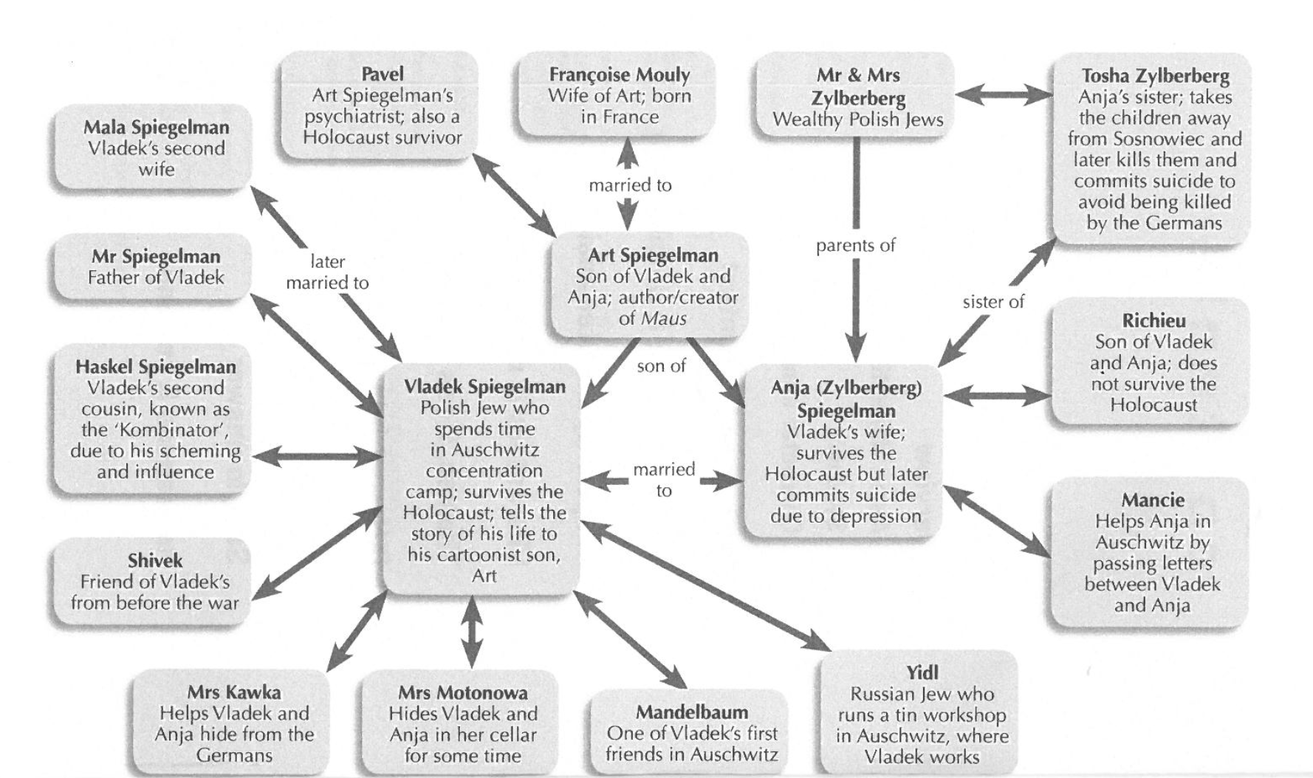

Know the author – Art Spiegelman
Art Spiegelman, (born Feb. 15, 1948, Stockholm, Swed.), American author and illustrator whose Holocaust narratives Maus I: A Survivor’s Tale: My Father Bleeds History (1986) and Maus II: A Survivor’s Tale: And Here My Troubles Began (1991) helped to establish comic storytelling as a sophisticated adult literary medium.

Spiegelman immigrated to the United States with his parents in 1951. The family settled in Queens, N.Y., and Spiegelman, inspired by the clever artwork and subversive humour of Mad magazine, studied cartooning. As a teenager, he attended Manhattan’s High School of Art and Design, and he embarked on a career as a professional artist, selling illustrations to the Long Island Post. He also began a two-decade run as a contributing artist and designer for Topps Chewing Gum, during which he helped develop the wildly successful Garbage Pail Kids and Wacky Packages trading cards. Spiegelman attended the State University of New York at Binghamton from 1965 to 1968, and he explored the alternative comics scene—most notably, the work of counterculture icon R. Crumb. After his mother’s suicide in 1968, Spiegelman left college without obtaining a degree, and he spent the early 1970s contributing to the flourishing comics underground. In 1972 he published two strips that represented a break from his previous work. The first was Maus, originally a three-page story that appeared in cartoonist Justin Green’s Funny Animals anthology. The second, Prisoner on the Hell Planet, was an attempt to understand his mother’s suicide through panels that evoked the bold intensity of German Expressionist woodcuts. These strips, along with other works, were collected in Breakdowns (1977).

In 1980 he cofounded Raw, an underground comic and graphics anthology, with his wife, Françoise Mouly. In it the pair sought to present graphic novels and “comix” (comics written for a mature audience) to a wider public. Recognized as the leading avant-garde comix journal of its era, Rawfeatured strips by European artists as well as previewed Spiegelman’s own work. Beginning in Raw’s second issue (December 1980), Spiegelman resumed the story of Maus, in which he related the wartime experiences of his parents, Vladek and Anja, both survivors of the Auschwitz death camp. Compelling in its ironic anthropomorphic animal depictions—the Jews and Nazis are drawn with the faces of mice and cats, respectively—its historical veracity, and its personal accounts, the story is made more complex by its contemporary framework. Spiegelman portrays himself as the adult Artie Spiegelman, who is attempting to understand and reconstruct his parents’ past while coping with the legacy of his mother’s death, his aging and often difficult father, and his own sense of guilt. The literary quality of Raw and Maus pushed comix into the mainstream, and their success led to Spiegelman working as a New York Times illustrator, a Playboy cartoonist, and a staff artist and writer for The New Yorker.

The commercial and critical success of Maus earned Spiegelman a “Special Award” Pulitzer Prize in 1992 and a solo exhibit at New York City’s Museum of Modern Art. In addition, Maus II became a New York Times best seller. Initially appearing on the fiction list, it was moved to nonfiction after Spiegelman appealed for the transfer on the basis of the book’s carefully researched factual scenes. The two Maus volumes were translated into more than 20 languages, and they were published together as The Complete Maus in 1996.

In 2000 Spiegelman and Mouly launched Little Lit, a comics anthology for children that collected work from comics creators Chris Ware, Neil Gaiman, and Daniel Clowes, children’s authors Maurice Sendak and Lemony Snicket, and humorist David Sedaris, among others. Although Spiegelman achieved success with lighthearted fare for young readers—his Open Me…I’m a Dog! (1997) was well received—he was inspired by the events of Sept. 11, 2001, to return to the comix format. Stating that “disaster is my muse,” Spiegelman published In the Shadow of No Towers (2004), a collection of broadsheet-sized meditations on mortality and the far-reaching consequences of that day. In 2008 he released Breakdowns: Portrait of the Artist as a Young %@&*!, which repackaged his long out-of-print Breakdowns collection as part of a longer graphic memoir. Spiegelman was made a Chevalier de l’Ordre des Arts et des Lettres in 2005.

Reference: https://www.britannica.com/biography/Art-Spiegelman

Considerations to make
- Why is it important to have an understanding of the author’s background?
- How does knowledge of Art Spiegelman’s background inform the reader further about the decisions made in Maus?

Know the story; know the background and context
Use the following links, as well as your own resources, to review the synopsis of the graphic novel (there is an abundance of other valuable information within these links too):
http://thecompletemaus.weebly.com/index.html

https://www.shmoop.com/maus/summary.html

http://www.gradesaver.com/maus/study-guide/summary

https://www.youtube.com/watch?v=lAvUD2a_kT8 - there are a whole series of these audio files on each chapter

http://englishtutorlessons.com.au/complete-maus-art-spiegelman-brief-synopsis-vce-year-12-english/

https://www.insightpublications.com.au/pdf_preview/TG_Preview_The_Complete_Maus.pdf

https://cdn.penguin.com.au/480/document/The%20Complete%20Maus.pdf

https://learn.stleonards.vic.edu.au/ibenglanglit/files/2013/10/The-Complete-Maus-VATE-Inside-Stories-2014-PDF.pdf ** This is a fantastic resource with helpful points of analysis (note: some parts are directed towards teachers but it is still helpful)

Know the genre, structure and language

The VATE Inside Stories document is a very helpful with this aspect of the study. Review your notes on genre, structure and language to ensure you have a strong understanding of the impact CONSTRUCT has on the reader’s experience with this graphic novel. Another interesting article exploring these concepts:
http://www.smh.com.au/national/education/many-layers-of-maus-20140206-325l2.html
Know the themes, ideas & values – mind-maps, notes, posters, previous responses; see activities in Insight text pp. 54-56

Other helpful resources
- http://www.history.ucsb.edu/faculty/marcuse/classes/33d/33dTexts/maus/MausResources.htm
- Writing the essay – use Insight text pp.64-69 to assist in planning and drafting your response

‘Island: collected stories’ by Alistair MacLeod

Know the characters
TITLE | Main Character & Age | Main Location | Themes & Ideas
‘The Boat’ | Unnamed older man; himself as a boy | Cape Breton | Tradition, education/literature, death
‘The Vastness of the Dark’ | James, 18 | Cape Breton; Nova Scotia | Tradition, transition, outsiders, belonging
‘The Golden Gift of Grey’ | Jesse, 18 | Indiana | Transition, education
‘The Return’ | Alex, 10 | Montreal; Nova Scotia | Tradition, transition, outsiders, belonging
‘The Lost Salt Gift of Blood’ | Unnamed man, 33 | Newfoundland | Transition, outsiders, belonging
‘The Road to Rankins Point’ | Calum, 26 | Cape Breton | Tradition, transition, belonging, death
‘The Closing Down of Summer’ | Unnamed miner, probably in his 50s | Cape Breton | Tradition, transition
‘To Every Thing There is a Season’ | Unnamed boy, 11 | Cape Breton | Transition, death
‘Second Spring’ | Unnamed boy, early teens | Not stated | Tradition, transition
‘Winter Dog’ | Unnamed older man, himself as a boy | Ontario; Cape Breton | Death
‘The Tuning of Perfection’ | Archibald, 78 (and as a younger man) | Cape Breton | Tradition
‘Vision’ | Unnamed man; his father, Alex, as a child and young man | Not stated | Tradition, death
‘Island’ | Agnes MacPhedran | Not stated | Tradition, transition, outsiders, belonging, death

Know the author
Alistair MacLeod, (born July 20, 1936, North Battleford, Saskatchewan, Canada—died April 20, 2014, Windsor, Ontario), Canadian author renowned for his mastery of the short-story genre.

MacLeod’s parents were natives of Cape Breton Island in northeastern Nova Scotia, and, when MacLeod was 10 years old, he and his family returned there. He worked as a miner and a logger before earning a teaching certificate from Nova Scotia Teachers College. He received a B.A. and a B.Ed. from St. Francis Xavier University, Antigonish, Nova Scotia, in 1960; a master’s degree from the University of New Brunswick at Saint John in 1961; and a Ph.D. from the University of Notre Dame in Indiana in 1968. He taught at Indiana University–Purdue University Fort Wayne from 1966 to 1969 and then returned to Canada as a professor of English and creative writing at the University of Windsor, Ontario (emeritus after 2000). For many years MacLeod also taught writing at the Centre for Continuing Education in Banff, Alberta.

MacLeod’s writing career began in 1968 with the publication of his short story “The Boat,” which was included in the 1969 anthology The Best American Short Stories. He drew critical acclaim after the appearance of his first collection, The Lost Salt Gift of Blood (1976); a second volume of stories, As Birds Bring Forth the Sun and Other Stories (1986), further solidified his reputation. MacLeod’s fiction chiefly examined the lives of the working people of Cape Breton—miners, loggers, fishermen, and farmers—and sensitively explored family relationships as well as the relationship of the islanders to their Celtic past.
MacLeod’s literary oeuvre is notable for its smallness. Together, The Lost Salt Gift of Blood and As Birds Bring Forth the Sun and Other Stories include only 16 stories, and each book took some 10 years to write. His lean output might be explained by his admitted perfectionism. A meticulous stylist, MacLeod revised constantly and read each of his sentences aloud in the belief that “the ear is a good editor.”

MacLeod’s long-awaited first novel, No Great Mischief, was published in 2000. It was written over the course of 13 years and chronicles the lives of several generations of Scottish immigrants on Cape Breton. MacLeod was the first Canadian writer to receive the International IMPAC Dublin Literary Award (2001). Until the award was announced, MacLeod had been largely unknown outside Canada. In part to satisfy the growing number of admirers of his work, he followed up No Great Mischief with Island: The Collected Short Stories of Alistair MacLeod (2000), which collected all of his previously published stories and included one new one. In 2004 he published To Everything There Is a Season: A Cape Breton Christmas Story, a novella adapted from a previously published short story and illustrated by Peter Rankin. In 2008 he was made an Officer of the Order of Canada, and in 2009 he shared the PEN/Malamud Award for short fiction with the American author Amy Hempel.

Reference: https://www.britannica.com/biography/Alistair-MacLeod

Know the stories
- Review your knowledge of the stories using your notes and resources. Here are the student summaries created this year to give you a start:

The Boat (1968) – p.1
- An older man reflects on his youth as the youngest in a Nova Scotian fishing family. He navigates tensions between his parents, the demands of family tradition, and the loss of his father at sea.’
- This short story consists of reflection, showing how family fall can apart; the mother plays a prominent role in the text. The boat is named Jenny Lynn, after his mother’s maiden name. This links his mother to a “chain of tradition” among the fishermen on the bitter-windswept island.
- The boat comes to represent so much more than just being a part of the family, it signifies the father’s failed dreams and his own sense of disappointment, both as a husband and father.
- To the son, the boat represents the father’s courage because he believes it was “very much braver to spend a life doing what you really do not want rather than selfishly following forever your own dreams and inclinations.”
- The story begins with author being on the boat, his father is dead and he feels alone, he lectures at a university and recalls the significance of the boat from a young age. The importance of the ocean is littered through his childhood home and his mother. As the story continues the audience learn of the contrasting views and values of his parents and their strained relationship. Dad is either smoking in his room or on the boat. Mother doesn’t approve of books and modern ideas. His sisters all marry wealthy and modern men at his mother’s disgust. Feels the strain of their relationship and he is left to help his father who drowns at sea one trip.

The Vastness of the Dark (1971) – p.26
- 18 year old dude named James wakes up on b-day.
- Thinking about life in a mining town on Cape Breton: his ancestors history of coalmining, his one trip down the tunnels, his grandfather and father’s careers in coal; his discovery of the nature of his conception as the eldest of eight kids; ponders his future and the future of his family.
- Anticlimactic farewell from his parents, his mother suggesting a place for him to go, his father setting him ‘free’.
- Grandparents’ farewell: grandmother knows there’s “nothing for one to do” at Cape Breton; grandfather knows he’ll forever be tied to the mines, “like the blood that a man puts in a woman.”
- James hitchhikes over the border, eventually hopping into a red car with arrogant and talkative driver, taking him to Springhill, another mining town on the mainland.
- At Springhill, James comes to the revelation that he doesn’t yet realize who he is, let along where he ought to be in whatever new life he’ll thrust himself into. Red-car-man’s representation of the commercial world outside of Nova Scotia shakes James into this revelation.
- James hops into the next care and it’s night. His travelling companions ask where he’s going, “I don’t know.” They drive into “the vastness of the dark” of the road, just as James’ family had drive into the darkness of coal and earth, and how James himself goes forward into a future now completely unguided.

The Return (1971) – p.79
- A young boy’s parents take him to visit his father’s coal-mining hometown; his father’s family welcomes them but his mother resists everything about their culture. The boy’s short visit with his family is both ordinary and magical, and there is a sense it will be his last.
- While told largely in the voice of young Alex, the story communicates clearly the conundrum in which his father, Angus, finds himself: he is forced to negotiate conflicting priorities. One is his beloved family’s devotion to their landscape and their shared history; the other is his wife, Mary, who is unable and unwilling to relate to such a culture
- As a young boy, he has not yet formed the relationships (whether positive or negative) with place and culture that his parents have
- However, he does soon experience group belonging for the first time, as his cousins take him easily into their collective, protecting him from others because he is ‘one of our own’ (p.88). This familial connection is one of the things for which his father longs
- Note the repetition of the word ‘never’ – suggests this visit to his family will be his only one.

The Lost Salt Gift of Blood (1974) – p.118
- A man arrives in Newfoundland, meets a young boy, stays overnight with the boy and his grandparents, reveals he’s the boy’s father, and eventually decides to return to his life elsewhere without the boy.
- Although told in the first person, the tone of this story is strangely distant. It contains long passages such as the first two pages, where the first-person ‘I’ is absent, making the narrative seem as though it is in third person
- The story is different to many of the others in that the protagonist is a stranger to the community in which it is set. His connection is not through his ancestry but through a possible future: John, his son
- Although never stated, the purpose of his return to Newfoundland appears to be claiming his son; but when he sees the community and family of which John is part of, he is reluctant to disrupt this in any way, even by identifying himself to the boy

The Road to Rankin’s Point (1976) – p.143
- Road to Rankin’s Point is built around the relationship of grandmother and grandson, Callum. They both share something in common, the horrible misfortune of dying or getting old.
- Callum, a twenty-six year old remembers his grandfather’s death on the roadside after the older man fell backwards against his rum bottle.
- We learn that the grandmother was also twenty-six when her husband dies.
- Callum returns to his family home to visit his grandmother, while he visits the family awkwardly gather at the family home to discuss the grandmother’s future. The family push the grandmother to leave the remote house hold but she tells them that Callum will stay with her.
- Callum initially returns to the family home to die but the farm doesn’t look like it used to; it’s rotting away and getting older just like the grandmother.
- The grandmother rejects anything that relates to change and rejects the modern society. This is why she is reluctant to move as she fears the nursing home.
- As he is telling his grandmother that he is dying himself, he soon after discovers his grandmother’s dead body near the roadside.

Island (1988) – p.369
- She is the youngest child (unexpected, born well after her other siblings)
- Family tradition of being the lighthouse operators on the island off the mainland
- Not many people lived on the island. She and her mother were the only females. People thought her family was a bit strange.
- Grandfather passed away young, so grandmother took over and then her father
- Age 17 --> met "the red-haired man"
- Was a young fisherman not from the area
- Met up more and more as they got to know each other at "the table rock"
- He proposed to her, promising they'd move away from the island and start a new life
- The night before he left they had sex
- He left to fish/work/do whatever for months --> not uncommon to do so for months at a time
- Months later all the fisherman returned, but not him. He had died during this time.
- She was pregnant with his baby
- Refused to tell people who the father was.
- People started spreading rumours and thought it was her father's
- Aunt on the mainland took the baby so they could return to the island to operate the lighthouse
- Father got sick, so he and the mother returned to the mainland. They both died not long after.
- Left alone on the island to maintain the lighthouse.
- Daughter on mainland didn't want a bar of her --> embarrassed
- Daughter ended up leaving the mainland and moved to Toronto --> she didn't even know
- Became known as the "mad woman" on the island
- Later on in her life, a boat of men came to the island fishing. She was lonely and she slept with them.
- Fell pregnant again, but miscarried
- Government came and told her they were replacing the maintenance of the lighthouse with "new technology" and she wouldn't be needed anymore
- Lonely. Lonely. Lonely.
- Imagined the red haired man coming back to the island. Went back to their meeting place and has a conversation with him (all in her head, practically a ghost)
She dies, her family legacy no longer lives on on the island

Know the themes, ideas & values – to ensure you demonstrate knowledge of a variety of stories, use tables like the one below in your revision:

Island by Alistair MacLeod. Revision sheet Page 1. THEMES: POINTS & QUOTES Write titles at top of each column. Add POINTS & QUOTES
How landscape influences/impacts upon IDENTITY – always an islander?
- remote, isolated, beautiful, hostile
Tradition vs Modern
- ‘fishing, farming and mining’ vs law, medicine, going away to university
- Globalization, travel & tourism
- Cultural loss vs preservation
- ‘outsiders’ & ‘non locals’
Familial bonds/love
- Father – son love
- romantic – man & woman
- Role of gparents/mothers
Conflict
- inner conflict
- b/w old ways & new ways, torn between both worlds
Importance of the past: how past affects present
- past shapes present identity
- can leave island physically but not psychologically
- Gaelic language & music
- LEGACY
Ever present nature death
- awareness of mortality
- matter-of-fact acceptance

Island by Alistair MacLeod. Revision sheet Page 2. STORY, STYLE & AUTHOR’S INTENTION Write titles at top of each column. Add POINTS & QUOTES
Story synopsis (point form)
- What happens?
- Where?
- Who?

Style points
- who is protagonist?
- retrospective narrator? present tense? 1st person? 3rd person?
- symbols
- metaphors
- imagery
- foreshadows? (gives hints, clues)
- HOW do characters demonstrate themes? what actions? words? thoughts?
- HOW does MacLeod describe settings?
- HOW does MacLeod reveal conflict?

Author’s intention?
- How does MacLeod want reader to feel? about characters? about island?

Review your notes and resources, particularly:

- The Island Study Tasks
- Island study summary notes
- Island – overview notes from Insight guide
- Your own Karen Graham lecture notes
Island: collected stories
Alistair MacLeod

Exploring Your Understanding of Island

Study Tasks

The following tasks are designed to assist in your preparation for both the SAC (creative response) and the work requirement (analytical response). You will need to read and re-read selected stories to deepen your knowledge and understanding of the narratives. ** All tasks should be completed in your workbook or on your device.

Characters

- Respond to the following by selecting one protagonist from a story in Island:
  - Personal details – their full name (and how to spell it), their age and where they live.
  - Character and personality – their strengths, weaknesses and significant values
- Background – their families; their social and cultural context.
- Motivations – why do they act in certain ways and make the choices they do?
- Relationships – with other characters and with their surroundings.
- Changes – in their character, relationships, circumstances or point of view

Common word | More specific words with similar meanings…
strong | powerful
weak | subservient
good | honourable
bad | immoral
kind | compassionate
nasty | malicious
quiet | reticent
loud | boisterous
true | honest
false | manipulative
loyal | committed
disloyal | treacherous
happy | positive
sad | negative
greedy | avaricious
nice | magnanimous
smart | perceptive
silly | unwise
rash | reckless
careful | cautious
brave | courageous
fearful | cowardly
thoughtful | reflective
practical | pragmatic
racist | bigoted
- Word bank for characters – to add interest and precision to your writing on texts, try describing characters using some of the words in the columns on the right. Fill in the blank spaces with words of your own:
Narrative point of view

First person – narrator of the story using ‘I’
Third person – a ‘voice’ that narrates the story using ‘he/she/they’ – does not use ‘I’

First person narration
Select one of the stories in Island written in the first person to answer the following questions:
- Analyse the advantages and disadvantages of first person narration by filling in the PMI chart –

Plus | Minus | Interesting
+ gives an ‘inside account of events  +  +  + | - limits the reader’s knowledge of characters to what the narrator knows of thinks of them  -  - | ! places the reader in the position of an involved participant  !  !

- How reliable is the narrator? Do we believe everything this character tells us about themselves and the world around them? Why or why not? Do they omit any important information?
- How might the writer’s view differ from the narrator’s? What makes you think this?
- Complete the following paragraph about the narrator of your text
_______________________________________________________________________________ (name of text) is narrated by ______________________________________________________________. He/she is a/an reliable/unreliable narrator, demonstrated by ______________________________________________________ __________________________________________________________________________________________ (evidence from the text). __________________________________________________ (name of the narrator) is ___________________________________________ and ___________________________________________ (two qualities exhibited by the narrator), as show by ________________________________________________
__________________________________________________________________________ (evidence from the text: behaviour or action of the narrator, another character’s description of them, a quotation from the text etc.)

Third-person narration
A text written in the third person tells the story from an outside, more detached point of view. We use the term omniscient narrator to describe this ‘all-knowing’ perspective. Third person also allows for a range of viewpoints to be presented. This is done with a shift from the ‘angle’ or perspective of one character to that of another and usually invites our sympathy for several characters because we can understand how they think and feel.

Select one of the stories in Island written in the first person to answer the following questions:
- Analyse the advantages and disadvantages of first person narration by filling in the PMI chart –

Plus | Minus | Interesting
+ can be omniscient (all-knowing) and therefore able to communicate various characters’ thoughts and feelings to the reader  +  + | - puts the reader in the position of being an observer rather than a participant  -  - | ! con convey multiple points of view on events and characters in the text  !  !

- Choose a short story from Island. Is the chapter written from a completely objective perspective? How do you know?

Orientation, setting and context

Orientation usually refers to the particular moment of entry into the narrative.
Setting refers to the places and times in which the action of the narrative occurs. A setting may be a natural or built environment. It may be vast or intimate, realistic or fanciful; it may be in the past, present or future.
Context is a broader term than setting. It encompasses real events and circumstances outside the world of the text. Three main contexts to consider are: historical, social and cultural.

Complete the following questions on setting and context:
- What is the main setting of your text?
- How is the setting described or depicted? Look for appeals to the five senses: sight, hearing, smell, taste and touch. Is the environment depicted as generally positive or negative?
- Find one quote from the text that describes and ‘sums up’ the setting.
- Write down three words of your own to describe the setting:
- What is the connection between the setting and the personalities of any of the characters in the text?
- What is the historical setting of the text?
- What historical references are made or alluded to in the text?
- Does the social context restrict or enhance the opportunities of the characters? If so, how?
- How is the author’s background relevant to the text?

Structure – key points in narrative structure

It is important to understand the structure of each narrative in Island for analysis, however this awareness will also help you to shape your own creative writing.

All narratives include key points or scenes that create rising and falling tension. Become familiar with and practise using metalanguage in the following table. In the right-hand column use each word in a sentence about your own text.

Word (metalanguage) | Definition | Your example (sentence)
Exposition | The introduction of the main characters and situation; the scene is set for some kind of conflict.
Crisis point | A character is presented with a problem or challenge that tests their values and beliefs
Turning point | A decisive change in the course of events; a character realises they cannot return to past circumstances; this can coincide with, or be the outcome of, a crisis point.
Climax | The point at which the tension rises to a peak; the main conflict between characters and/or ideas comes to a head and must be resolved.
Denouement | The ‘unknotting’ or unraveling of narrative threads; when questions are finally answered.
Resolution | Where the tension relaxes – conflicts are resolved, issues and relationships are sorted out.

Themes

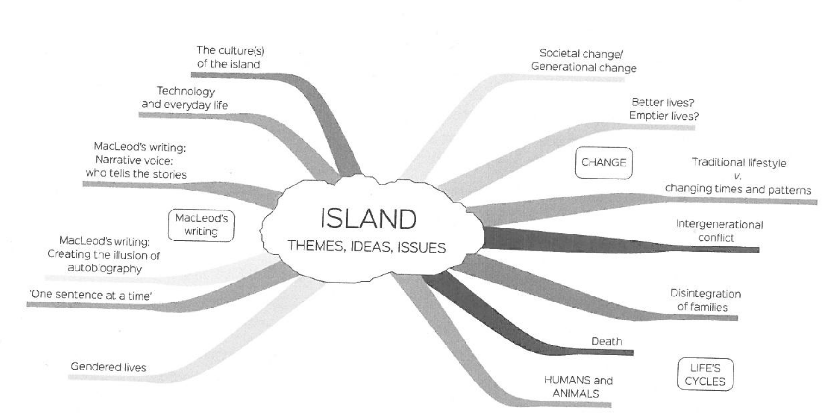
Take a close look at the map of possible themes in Island below. Practise writing about theme by creating a simple statement using the template as a guide.

Events and Experiences | What do I learn about the character? | What important themes emerge?
Example – Event/Story
Calum in The Road to Rankin’s Point. Returns to his grandmother
Event/Story 1:

Event/Story 2:

Event/Story 3:

- Writing about theme

A major them of Island is _____________________________________________. MacLeod suggests that ___________
_______________________________________________________________________________________________________________________________________________________________________________________ (author’s point of view on the theme). He suggests this by__________________________________________________________ ________________________________________________________________________________________________
_______________________________________________________________ (one piece of evidence from a character). It is also suggested by ______________________________________________________________________________
________________________________________________________________________ (one piece of evidence from a plot) and by _______________________________________________ (character’s name)’s words, ‘________________
______________________________________________________________________’ (key quotation about the theme).

- Choose three significant events from three separate stories in Island and complete the table below to show the links between characters and themes.

Values

Characters embody values through their thoughts, feelings, attitudes, relationships, beliefs, statements and actions. We respond to characters largely by responding to the values they hold – or to the fact that they appear to have no values.

Culture can also play a role: different cultures can place more or less emphasis on different values; this is often shown through the characters.

- Consider the values in the table below and complete the table with definitions and examples of characters who demonstrate these values in Island.

Key value  (e.g. doing what is right) | Definition | Characters who demonstrate this value, and how
loyalty
working hard
taking responsibility
Opposite of key value  (e.g. doing what is wrong) | Definition | Characters who demonstrate the opposite of the key value, and how
disloyal
laziness
not taking responsibility

- Writing about values
Fill in the gaps in the sentences below, using evidence from one of the stories in Island to support your view. Look at how the characters think, the views they express and the decision they make. Consider also the consequences of the characters’ behaviour – this can show the writer’s approval or disapproval of their values or the values of their society.

    - The key qualities associated with the protagonist in _______________________________ (name of story) are ___________________________________________________________________________________.
    - He/she believes in _______________________________________________________________________.
    - We know this because ____________________________________________________________________.
    - The protagonist’s value reflect/challenge the society’s values because _______________________________
______________________________________________________________________________________.
    - One character who supports the protagonist’s position is _________________________________________.
    - The writer endorses/criticises ___________________________’s values by__________________________
______________________________________________________________________________________.
The resolution of the story suggests that ______________________________________________________
______________________________________________________________________________________.

Special features of short stories

Concentrated story structure

In a novel, narrative tension may rise and fall a number of times before the climax is reached and conflict is resolved. In a short story (like those in Island), you are more likely to find a pattern similar to that shown in the diagram below.

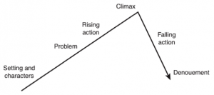
END
Resolution
Dramatic Tension
START

Links between stories

In studying Island, you need to develop an in-depth understanding of individual stories and explore connections or ideas that link the stories together.
- Explore how the stories explore various aspects of a theme
- Explore how the stories are linked by recurring elements, e.g. character types, similar settings, repeated stylistic features (such as juxtaposition)
- Explore how a linking idea may be explored from different perspectives in different stories e.g. male/female viewpoints, father/son perspectives.

How to write about short stories in a collection

Keep the following points in mind when writing a text response on Island (this will also assist you when planning for your creative response so you see the ‘big picture’ of the collection).

- Refer only to three or four stories in a text response essay – any more than this becomes difficult to manage
- Give the complete names of the characters (if they are available) the first time you reference them, and mention the titles of the stories they appear in
- Place quotation marks around the title of each story you refer to, and underline the title of the collection (this helps to distinguish what you are referring to – a story or a collection)
- Draw on evidence from the stories in the same way you would draw on evidence for any other novel, play etc.
- Try not to jump from one story to another in the same paragraph. Rather, work from a general topic sentence to focusing on a particular story in order to highlight an aspect of your argument.

Exploring themes and issues in the collection

Select three or four stories from Island you think best demonstrate a particular theme and make notes on the characters, plot or other elements that the writer uses to present this theme. Choose a key quote that relates to the theme from each story, then make notes on how the evidence you have selected relates to the theme.

Key theme:
Story title | Evidence (characters, plot etc) | Key quotation | Link to theme

Exploring links between stories in Island

Answer the following questions to explore possible links between stories and identify common concerns running through the collection as a whole:

      - Write down any associations or ideas that the title of the collection makes you think of (e.g. isolation)
      - What are the main settings of each story? (be more specific than Cape Breton)
      - What recurring settings are present?
      - Identify recurring character types (fathers, sons etc)
      - In one paragraph, discuss links that you have identified and how they relate to the main concerns of the collection as a whole. Here’s a sample answer:
Many of the short stories in Alistair MacLeod’s Island have coastal settings and feature characters who are experiencing, or are reflecting on, periods of transition in their lives. The coast is in between land and water, and is constantly changing; it thus mirrors the state of uncertainty flux described by several main characters and narrators. In ‘The Boat’, the narrator describes the year in which he helped his father on the boat, caught between his love of books and his love of the sea. In ‘Island’, the main character is the first person to be born on the island, where she later becomes the last lighthouse keeper, marking another kind of transition. The stories thus explore the many facets of change, particularly the loss of traditions and of connections to place.

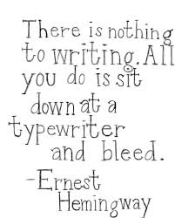
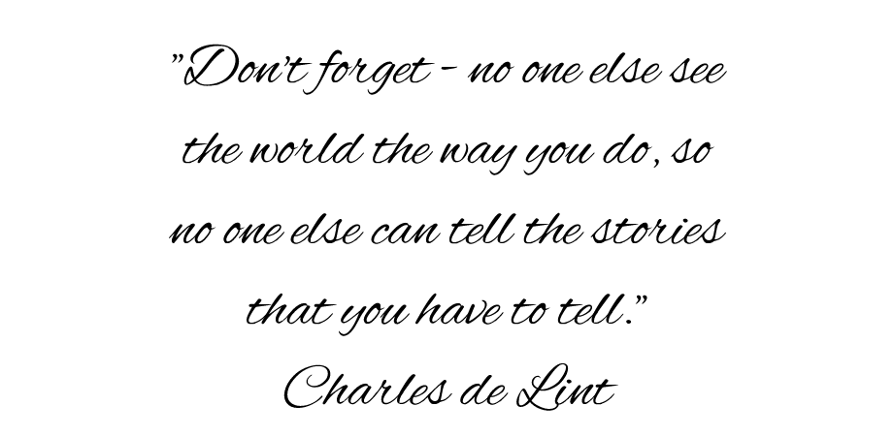

GOOD LUCK!

Section B – Comparative analysis of texts (20 marks)
Pair 7 - ‘Black Diggers’ by Tom Wright, and ‘The Longest Memory’ by Fred D’Aguiar

SECTION B EXAM TIPS – Check off the items as you address them in your revision!
Below are exam tips to assist students to analyse texts and prepare for the final year exam.

- Students should re-read both of the texts by start of term four, to prepare for the close textual analysis required for assured comparative text essay writing.

- Students should develop a comprehensive document to compare and contrast elements from the two texts, including parallel or contrasting succinct quotations.

- Students should memorise quotations which shed light on core issues and ideas in each text.

- Students should practise and refine the approach to comparative essay writing which proves to be most suitable and reliable.

- Students should write practice introductions and conclusions which clearly and deliberately compare and juxtapose the two texts.

- Students should practise appropriately addressing and responding on the different styles of topic which may be used.

- Students should develop an extensive list of issues, ideas and themes which arise through the comparison of the texts.

- Students should identify the most apparent differences, as well as similarities, between the texts.

- Students should analyse the significant stylistic and structural approaches used by the writer or filmmaker of each text, and how these have impacted on the presentation of the main ideas, issues and themes.

- Students should have a knowledge of words, phrases and clauses which most readily connect the texts to aid comparison

Section C – Argument and persuasive language (20 marks)

Still to come…

